Import File to Workspaces Script (MJ)
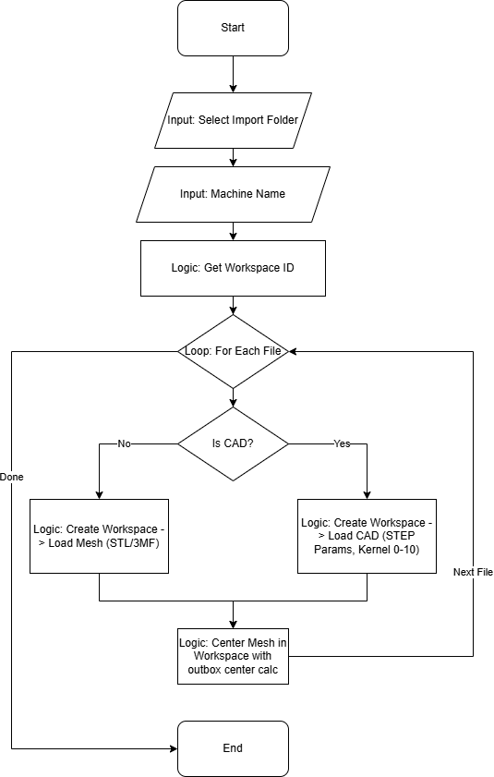
Script Name: import_file_to_workspaces_MJ.lua

Functionality
This script automates the batch import of part files (both Mesh and CAD) from a directory. For each file, it creates a dedicated Workspace (tray) assigned to a specific machine, ensuring accurate build time and cost estimates.
Logic Flow:
- Machine Selection: The user specifies a target machine (e.g., "Fuse 1"), and the script resolves the internal Workspace ID.
- Batch Processing: It iterates through every file in the selected directory.
- Importer Selection:
  - Standard Meshes (STL, 3MF): Imported directly.
  - CAD Files (STEP): Imported using a specialized loop that tries 11 internal kernel indices (0-10) to find a compatible importer. It also supports custom tessellation parameters.
- Placement: Each part is placed in its own new workspace and automatically centered.

User Guide (Quick Start)
- Prepare a folder containing all the files you wish to process.
- Run the script import_file_to_workspaces_MJ.
- Select the import folder when prompted.
- Enter the exact Machine Name (as listed in "My Machines") when asked (default is "Formlabs Fuse 1").
- If prompted for STEP parameters (Deviation, Angle, Edge Length), accept the defaults or customize them.
- The script will generate a separate workspace for every file.

Code Maintenance & Technical Notes
Workspace vs. Tray: The script explicitly uses trayHandler:addworkspace(workspaceID) instead of generic tray creation. This ensures that the specific machine configuration (and thus "No-Build" zones) is applied.
STEP File Handling: Standard mesh loaders fail on STEP files. The script implements a robust loadcadfile function that attempts to create a CAD importer using indices 0 through 10. This loop is critical for compatibility across different Netfabb versions and kernel states.
Centering Logic: Parts are centered based on the machine dimensions retrieved from the new workspace (`machinesize_x`, `machinesize_y`) relative to the part's bounding box.

